CALCX
Modern Calculator
Front-End Development Project
Built with HTML • CSS • JavaScript
Author: Mohammad Sajeed

1. Project Overview
CalcX is a modern, responsive web-based calculator developed for Task 2. It implements core arithmetic operations through an interactive interface and extends the basic requirements with keyboard support, calculation history, theme switching, copy-to-clipboard functionality, responsive design, animations, and error handling.
2. Objectives
- Build a functional calculator using HTML, CSS, and JavaScript.
- Implement addition, subtraction, multiplication, division, and modulus operations.
- Provide an intuitive button-based interface with a dedicated display.
- Handle user input, clearing, deletion, decimals, and real-time result updates.
- Add keyboard support as a bonus feature.
- Create a polished responsive design for desktop and mobile screens.
3. Technologies Used
Technology | Purpose | Implementation
HTML5 | Structure | Calculator layout, display, buttons, history panel
CSS3 | UI / Styling | Responsive layout, glass-style cards, themes, animations
JavaScript | Functionality | Arithmetic logic, events, keyboard handling, history

4. Key Features
- Arithmetic Operations – Supports +, −, ×, ÷ and %.
- Real-Time Display – Updates input and selected operation immediately.
- AC / DEL Controls – Resets the calculator or removes the latest digit.
- Decimal Support – Prevents duplicate decimal points in a number.
- Keyboard Support – Supports numbers, operators, Enter, Backspace, Escape and C.
- Calculation History – Displays recent calculations in a dedicated panel.
- Clear History – Removes stored history entries.
- Copy Result – Copies the current result to the clipboard.
- Theme Toggle – Switches between dark and light appearance.
- Responsive UI – Adapts to desktop and mobile screen sizes.
- Error Handling – Safely handles invalid calculations and division by zero.

5. Project Output
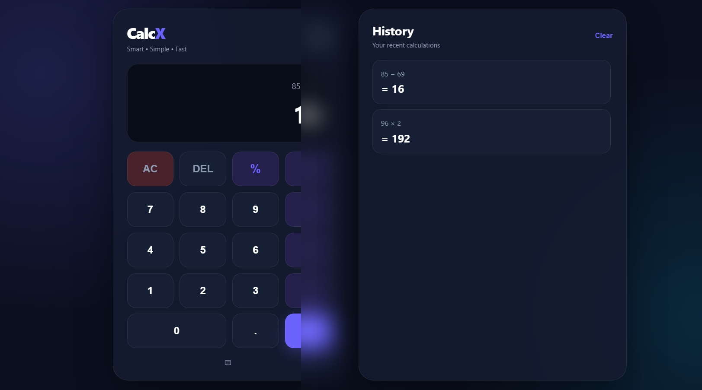
Figure 1. CalcX calculator interface with recent calculation history
7. Project Structure
Calculator/
├── index.html – Calculator interface and page structure
├── style.css – Visual design, responsive layout and themes
├── script.js – Calculator logic and user interactions
└── README.md – Project documentation for GitHub
8. Testing and Validation
Test Case | Expected Result | Status
85 − 69 | 16 | Passed
96 × 2 | 192 | Passed
Addition / Division | Correct arithmetic result | Passed
Decimal input | Valid decimal calculation | Passed
Delete button | Last digit removed | Passed
AC button | Display reset to 0 | Passed
Division by zero | Error handled safely | Passed
Keyboard input | Keys trigger calculator actions | Passed
9. Future Enhancements
- Add scientific calculator functions such as square root, powers, and trigonometry.
- Persist calculation history using localStorage.
- Add timestamps and searchable history.
- Improve accessibility with ARIA labels and keyboard focus states.
- Add automated unit tests for calculation logic.
10. Conclusion
CalcX successfully fulfills Task 2 by providing a functional calculator with the required arithmetic operations, interactive display, input controls, clearing, and real-time results. The project also demonstrates additional front-end skills through keyboard support, history management, theme switching, clipboard support, responsive design, and polished UI styling.

